Conclusion And Summary of Project

Retail Analysis

Firstly we did clustering based on RFM analysis. We had 4 clusters/Segmentation of customers based on RFM score.

Later we implemented the machine learning algorithm to cluster the customers

|  |  |  |  |
| --- | --- | --- | --- |
| Sr. No. | Model Name | Data | Optimal Number of Clusters |
| 1 | Kmeans with Elbow method(Elbow visualizer) | Recency and Monetory | 2 |
| 2 | Kmeans withSilhouette score method | Recency and Monetory | 2 |
| 3 | DBSCAN | Recency and Monetory | 2 |
| 4 | Kmeans with Elbow method(Elbow visualizer) | Frequency and Monetory | 2 |
| 5 | Kmeans withSilhouette score method | Frequency and Monetory | 2 |
| 6 | DBSCAN | Frequency and Monetory | 2 |
| 7 | Kmeans with Elbow method(Elbow visualizer) | Recency, Frequency, Monetory | 2 |
| 8 | Kmeans withSilhouette score method | Recency, Frequency, Monetory | 2 |
| 9 | DBSCAN | Recency, Frequency, Monetory | 2 |
| 10 | Hierarchical Clustering | Recency, Frequency, Monetory | 2 |

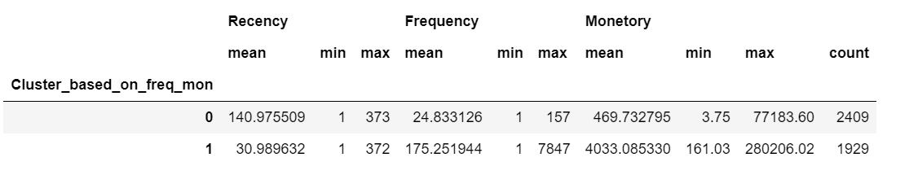

* Above clustering is done with recency, frequency and monetory data(Kmeans Clustering) as all 3 together will provide more information.
* Cluster 0 has high recency rate but very low frequency and monetory. Cluster 0 contains 2409 customers.
* Cluster 1 has low recency rate but they are frequent buyers and spends very high money than other customers as mean monetary value is very high. Thus generates more revenue to the retail business.

With this, we are done with our project. Also, we can use more robust analysis for the clustering, using not only RFM but other metrics such s demographics or product features.